K8s Notes

Kubernetes
Kubernetes is an open-source container orchestration platform used to automate deployment, scaling, load balancing, and management of containerized applications in production environments.

Kubernetes Architecture
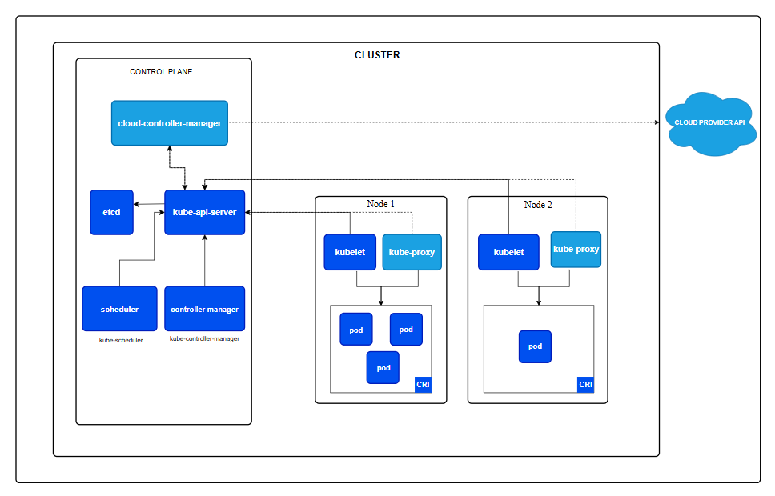

Pod Lifecycle
Pending | The Pod has been accepted by the Kubernetes cluster, but one or more of the containers has not been set up and made ready to run. This includes time a Pod spends waiting to be scheduled as well as the time spent downloading container images over the network.
Running | The Pod has been bound to a node, and all of the containers have been created. At least one container is still running, or is in the process of starting or restarting.
Succeeded | All containers in the Pod have terminated in success, and will not be restarted.
Failed | All containers in the Pod have terminated, and at least one container has terminated in failure. That is, the container either exited with non-zero status or was terminated by the system, and is not set for automatic restarting.
Unknown | For some reason the state of the Pod could not be obtained. This phase typically occurs due to an error in communicating with the node where the Pod should be running.

Pod lifecycle states:

Pending → ContainerCreating → Running
Running → (Success | CrashLoopBackOff | Failed)

Pending
Pod is created but not scheduled yet (no node / resources / PVC issue).
ContainerCreating
Pod is assigned to a node.
Kubernetes is pulling image, mounting volumes, setting network.
Running
Container is started.
Running ≠ Ready (readiness probe decides traffic).
Success (Completed)
Container finished successfully (exit code 0).
Used in Jobs / CronJobs.
CrashLoopBackOff
Container keeps crashing and restarting.
Kubernetes retries with delay.
Failed
Container exited with error (non-zero exit).
No restart (usually Jobs).

CLUSTER & CONTEXT
- kubectl cluster-info
- kubectl config get-contexts
- kubectl config use-context <context-name>
- kubectl get nodes
- kubectl describe node <node-name>

PODS Commends:
- kubectl get pods
- kubectl get pods -o wide
- kubectl get pods -w
- kubectl describe pod <pod-name>
- kubectl logs <pod-name>
- kubectl logs <pod-name> -p
- kubectl exec -it <pod-name> -- /bin/bash
- kubectl delete pod <pod-name>

WAYS TO CREATE PODS IN KUBERNETES
Using kubectl run (Quick / Testing)
- kubectl run nginx-pod --image=nginx
Using YAML File (BEST PRACTICE)
apiVersion: v1
kind: Pod
metadata:
name: nginx-pod
labels:
app: nginx
spec:
containers:
- name: nginx-container
image: nginx:latest
ports:
- containerPort: 80
kubectl apply -f pod.yaml ------ to run this yaml
Create Pod with Command + YAML Output
kubectl run nginx --image=nginx --dry-run=client -o yaml > pod.yaml – it will create pod + yaml
kubectl apply -f pod.yaml
Pod in a Specific Namespace
kubectl run nginx --image=nginx -n dev

Deployment yaml
apiVersion: apps/v1
kind: Deployment
metadata:
name: nginx-deployment
labels:
app: nginx
spec:
replicas: 3
selector:
matchLabels:
app: nginx
template:
metadata:
labels:
app: nginx
spec:
containers:
- name: nginx
image: nginx:latest
ports:
- containerPort: 80

Service
For some parts of your application (for example, frontends) you may want to expose a Service onto an external IP address, one that's accessible from outside of your cluster.
Kubernetes Service types allow you to specify what kind of Service you want.
The available type values and their behaviors are:
ClusterIP
Exposes the Service on a cluster-internal IP. Choosing this value makes the Service only reachable from within the cluster. This is the default that is used if you don't explicitly specify a type for a Service. You can expose the Service to the public internet using an Ingress or a Gateway.
NodePort
Exposes the Service on each Node's IP at a static port (the NodePort). To make the node port available, Kubernetes sets up a cluster IP address, the same as if you had requested a Service of type: ClusterIP.
LoadBalancer
Exposes the Service externally using an external load balancer. Kubernetes does not directly offer a load balancing component; you must provide one, or you can integrate your Kubernetes cluster with a cloud provider.

ExternalName
Maps the Service to the contents of the externalName field (for example, to the hostname api.foo.bar.example). The mapping configures your cluster's DNS server to return a CNAME record with that external hostname value. No proxying of any kind is set up.

Service YAML

ClusterIP Service:
apiVersion: v1
kind: Service
metadata:
name: nginx-service
spec:
type: ClusterIP
selector:
app: nginx
ports:
- port: 80
targetPort: 80

NodePort Service:
apiVersion: v1
kind: Service
metadata:
name: nginx-nodeport
spec:
type: NodePort
selector:
app: nginx
ports:
- port: 80
targetPort: 80
nodePort: 30080
http://<node-ip>:30080 -- To Access

LoadBalancer Service (Cloud):
apiVersion: v1
kind: Service
metadata:
name: nginx-lb
spec:
type: LoadBalancer
selector:
app: nginx
ports:
- port: 80
targetPort: 80

Important Rules
  - selector → must match Deployment labels
  - port → Service port
  - targetPort → Container port

ConfigMap
- ConfigMap is a place to store application settings in Kubernetes.
- Instead of writing settings inside your code or Docker image, you keep them outside.
- it is like a variables.

Simple configmap:

Configmap.yaml:

apiVersion: v1
kind: ConfigMap
metadata:
name: nginx-config
data:
APP_ENV: "dev"
LOG_LEVEL: "info"

Deployment.yaml

apiVersion: apps/v1
kind: Deployment
metadata:
name: nginx-deployment
spec:
replicas: 2
selector:
matchLabels:
app: nginx
template:
metadata:
labels:
app: nginx
spec:
containers:
- name: nginx
image: nginx
ports:
- containerPort: 80
envFrom:
- configMapRef:
name: nginx-config
env:
- name: APP_ENV
valueFrom:
configMapKeyRef:
name: nginx-config
key: APP_ENV

Use ConfigMap as File (Advanced):

volumeMounts:
- name: config-volume
mountPath: /etc/config
volumes:
- name: config-volume
configMap:
name: nginx-config

- volumeMounts → attach storage to container
- name: config-volume → reference volume name
- mountPath: /etc/config → location inside container
👉 Kubernetes will create files in /etc/config
- volumes → define storage
- configMap → source is a ConfigMap
- name: nginx-config → use this ConfigMap

Secret
Secret is like ConfigMap, but for sensitive data.
ConfigMap | Secret
Normal values | Sensitive values
Can be seen easily | Encoded (base64)
Example: LOG_LEVEL | Example: DB_PASSWORD

What We Store in Secrets (Real Time)
Common Real-World Examples
- Database password
- API keys
- Tokens
- OAuth secrets
- SSL certificates
- Docker registry credentials

Secret YAML:
apiVersion: v1
kind: Secret
metadata:
name: db-secret
type: Opaque
data:
DB_USER: YWRtaW4=
DB_PASSWORD: cGFzc3dvcmQ=

How base64 works (Simple)
echo -n admin | base64
echo -n password | base64

Use Secret in Deployment (Like Variables)
env:
- name: DB_USER
valueFrom:
secretKeyRef:
name: db-secret
key: DB_USER
- name: DB_PASSWORD
valueFrom:
secretKeyRef:
name: db-secret
key: DB_PASSWORD

Use Secret as File (Advanced but Common)
volumeMounts:
- name: secret-volume
mountPath: /etc/secrets

volumes:
- name: secret-volume
secret:
secretName: db-secret

Ingress – simple explanation
Ingress is used to access your application from outside the Kubernetes cluster using HTTP/HTTPS (browser, API calls).
Think like this 👇
User (Browser)
↓
Ingress (Traffic Controller)
↓
Service
↓
Pod (Application)

Why Ingress is needed?
Without Ingress:
- You use NodePort → ugly port like :30000
- Or LoadBalancer → costly in cloud
With Ingress:
- Access using domain name
- One public entry point for many services
- Supports path-based & host-based routing
- SSL (HTTPS) support

Simple Ingress YAML example
apiVersion: networking.k8s.io/v1
kind: Ingress
metadata:
name: app-ingress
spec:
rules:
- host: myapp.local
http:
paths:
- path: /
pathType: Prefix
backend:
service:
name: frontend-service
port:
number: 80

Configure Local DNS (IMPORTANT)
Get Minikube IP:
minikube ip
Example:
192.168.49.2
Edit hosts file
Linux / Mac
sudo nano /etc/hosts
Windows
Edit as Administrator:
C:\Windows\System32\drivers\etc\hosts
Add:
192.168.49.2 nginx.local
Save file.

STEP 6️⃣ Test in Browser 🌍
Open browser:
http://nginx.local
✅ You will see Nginx Welcome Page
For example use: https://github.com/RagavMuthukumar/k8_ingress.git

Probes:
health of your application so it can:
- send traffic only to healthy pods
- restart broken pods automatically

Types of probes:
- Readiness Probe
- Liveness Probe
- Startup Probe

Readiness Probe:
If Pod Fails it will restart the container.

Liveness Probe:
If pod fails it will remove the pod from your service. It will stop the traffic sent to the pod.
Probe | Purpose | Action
Readiness | Ready to serve traffic | Remove from Service
Liveness | App is alive | Restart pod
Startup | App startup check | Delay other probes

initialDelaySeconds: 5 # timing 5 sec -- when it need to start after pod created
periodSeconds: 10 #timing 10 sec -- how many sec once it should run
timeoutSeconds: 2 #timing 2 sec -- how many sec it need wait for result
failureThreshold: 3 #count 3 -- how many time it will consider to conform failure
successThreshold: 2 #count2 -- how many time it will consider to conform success

In Deployment.yaml

readinessProbe: # Checks if pod is ready to receive traffic
httpGet:
path: /health
port: 80
initialDelaySeconds: 5
periodSeconds: 10

livenessProbe: # Checks if pod is alive; restarts if failed
httpGet:
path: /health
port: 80
initialDelaySeconds: 15
periodSeconds: 20

